Day 4 task:

1.comparing 2 JSON have same properties without same order

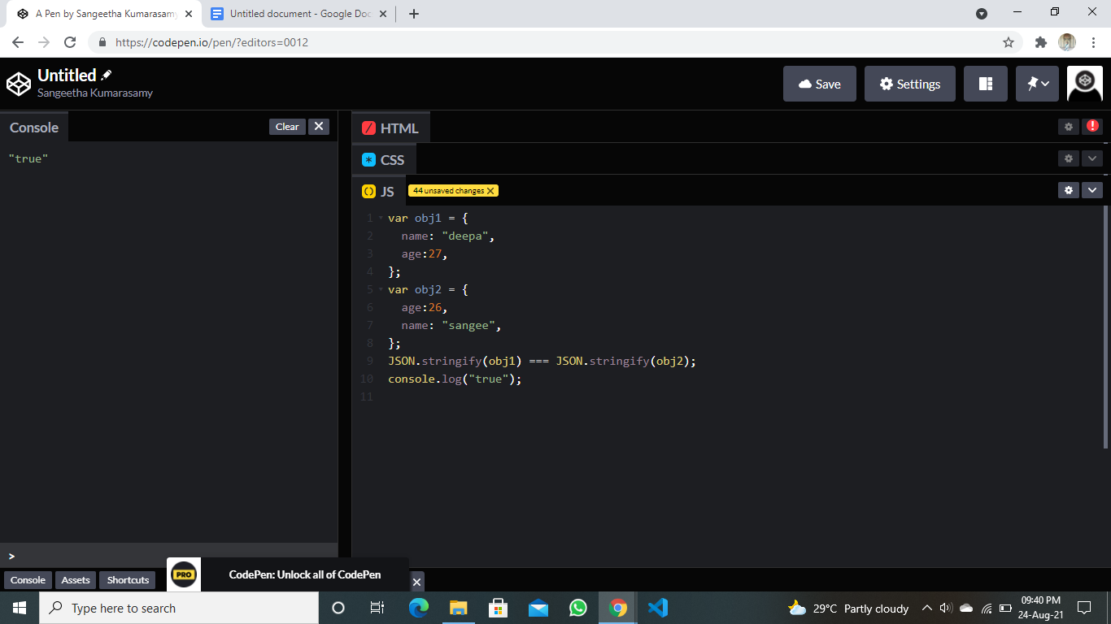

2. Flags of the countries

<https://codepen.io/SangeethaKumarasamy/pen/powgvwy?editors=1111>

3.Name,region,sub-region,population -of the countries

<https://codepen.io/SangeethaKumarasamy/pen/qBjbEwJ>